**Create IBM DB2 And Connect With Python**

|  |  |
| --- | --- |
| Team ID | PNT2022TMID26524 |
| Project Name | NUTRITION ASSISTANT APPLICATION |

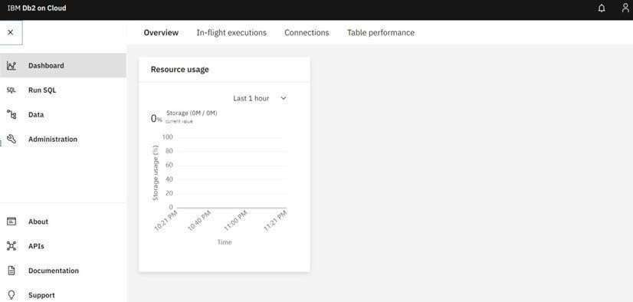

**IBM DB2:**

**DB2 with python:**

